ASSEMBLY 3471 NEWSLETTER June 2019

Greetings Sir Knights
This newsletter is to keep the St Mary’s Assembly 3471 Sir Knights informed of upcoming activities, meetings, and to report on our activities. If you have anything you want to get into future newsletters send them to Joe Wuest, famwuest4@gmail.com
New Members of Assembly 3471

We welcomed two new members to the Assembly at a 4th Degree Exemplification on Saturday June 15th. The Exemplification was at St Francis Cabrini Church and there were over 50 candidates. Deacon Greg Frank and Glenn Prolux are our two new 4th Degree members. After the exemplification there was a Mass, knighting of the new members and a very good meal. There was also a moving flag history ceremony after dinner.
Congratulate Worthy Sir Knights Deacon Greg and Glenn next time you see them.
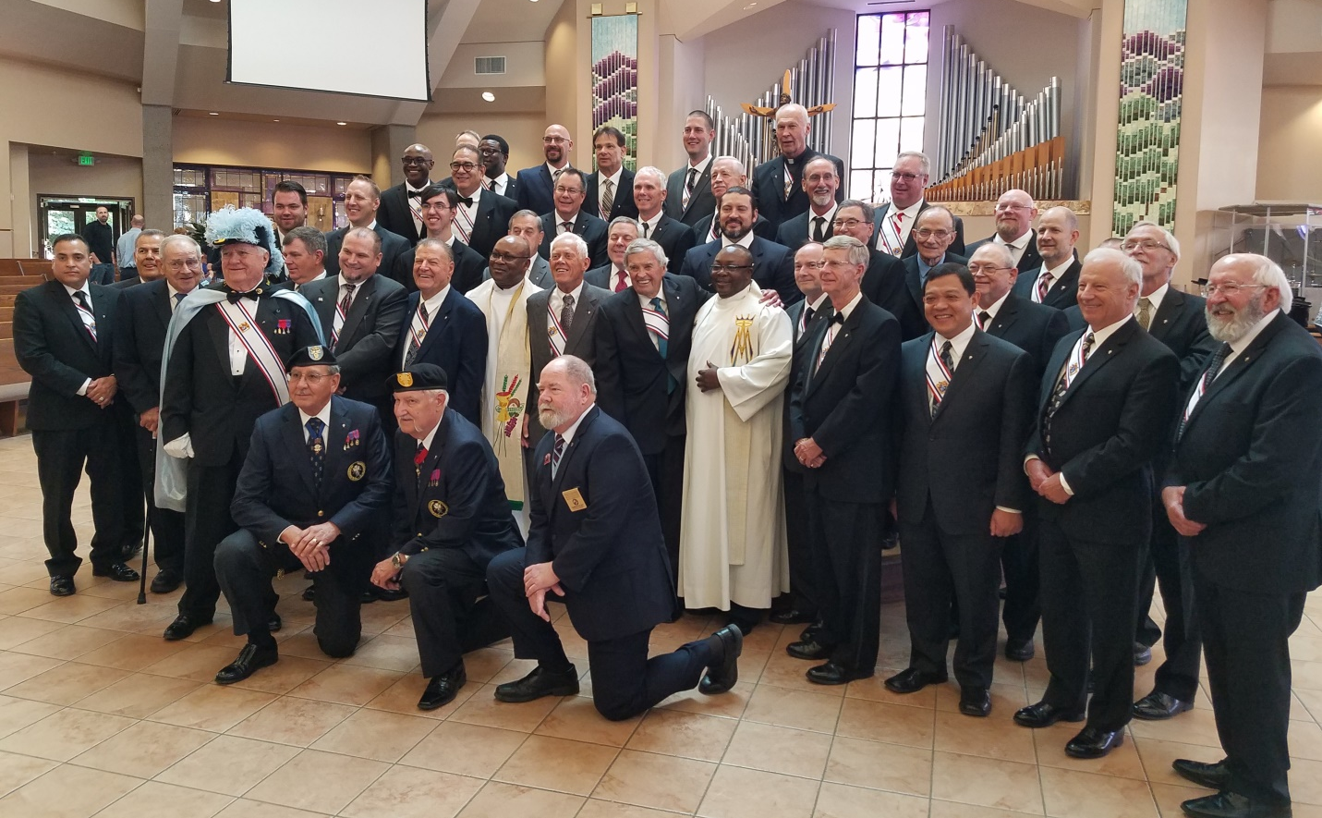
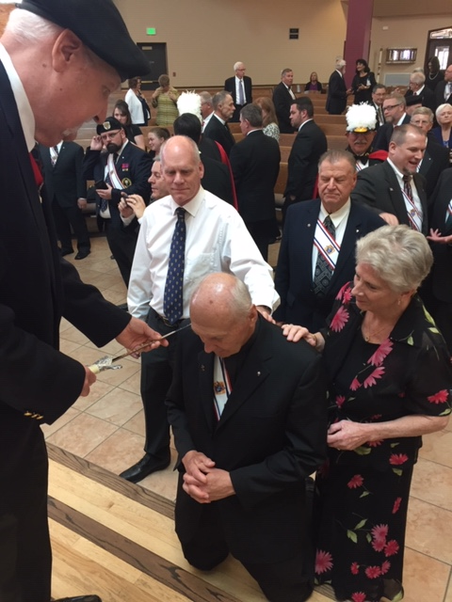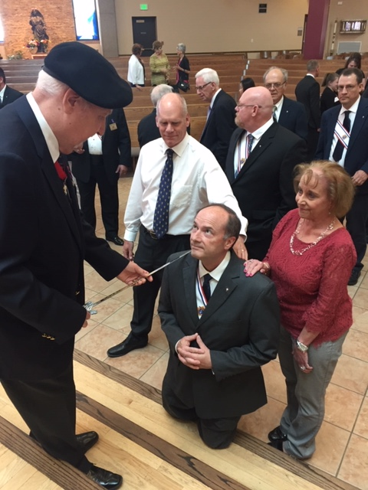

Assembly Officer Installation and Dinner
The Assembly will have its installation of officers and a dinner on Wednesday July 24th in Marian Hall starting at 6:30 pm. Everyone is invited along with their family. We will start with the installation of officers (see list below) and then have a dinner. We will need an Honor Guard for the installation.
Faithful Navigator – Joe Wuest
Faithful Comptroller – Jack Mascio
Faithful Friar – Deacon Greg Frank
Faithful Captain – Carl Kruse
Faithful Admiral – Calton Hargrave
Faithful Purser – Roy Ladewig
Faithful Pilot – Dave Nila
Faithful Scribe – George Stragand
Inner Sentinal – Joe Kirby
Outer Sentinal – Andy Vu
One Year Trustee – William Wagener
Two Year Trustee – Douglas Linhardt
Three Year Trustee – Bill Kehrman

Cal Hargrave will be the Color Corp Commander

Assembly 3471 Honor Guards
The St. Mary’s Assembly recently provided several members as Honor Guard for the Kendrick Castillo Rosary and Funeral at St. Mary’s. We had 3 members at the Rosary and 5 at the Funeral. Overall there were 35 Honor Guard from across the state at the Rosary and over 80 at the Funeral. It was very a very impressive showing to honor Kendrick Castillo’s heroism.

Assembly Website
The Assembly now has a website – it is attached to the Council 3340 website. Go to kofc3340.org and there is a link in the left side list “Assembly Links” From there click on the “3471” link. The website is still getting populated, if there is anything you would like added to the website contact Joe Wuest at famwuest4@gmail.com

Calendar Tentative Dates are in Blue

7-24, 2019 Assembly Officers Installation.
Ava Maria Hall 6:30 p.m. Light meal to follow.
Witness one of the nicest ceremonies in the Patriotic Degree!

8-19, 2019 Metro Chapter Meeting
Council 539’s Hall, 1515 Grant Street, Denver
Dinner between 6:00 and 6:30, Meeting to start 7:00 p.m.
See and hear what is going on with other Assemblies and Councils.
Opportunity to talk with a State Officer.

9-29, 2019 Corporate Communion. Saint Mary Catholic Church
9:30 Mass Preceded by Rosary

10-26, 2019 Patriotic Degree Exemplification.
Our Lady of the Pines, Windsor, CO
Registration starts 11:00 a.m.
Contact: Chuck Rohrer - 970-672-6109 charlesrohrer6@gmail.com
Let’s recruit our council’s 3rd degree Knights.

12-29, 2019 Corporate Communion. Saint Mary Catholic Church
9:30 Mass Preceded by Rosary

Assembly 3471 Good of the Order
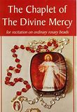

How to Recite the Chaplet
1. Make the Sign of the Cross
In the name of the Father, and of the Son, and of the Holy Spirit. Amen.

2. Optional Opening Prayers
You expired, Jesus, but the source of life gushed forth for souls, and the ocean of mercy opened up for the whole world. O Fount of Life, unfathomable Divine Mercy, envelop the whole world and empty Yourself out upon us.
(Repeat three times)
O Blood and Water, which gushed forth from the Heart of Jesus as a fount of mercy for us, I trust in You!

3. Our Father
Our Father, Who art in heaven, hallowed be Thy name; Thy kingdom come; Thy will be done on earth as it is in heaven. Give us this day our daily bread; and forgive us our trespasses as we forgive those who trespass against us; and lead us not into temptation, but deliver us from evil, Amen.

4. Hail Mary
Hail Mary, full of grace. The Lord is with thee. Blessed art thou amongst women, and blessed is the fruit of thy womb, Jesus. Holy Mary, Mother of God, pray for us sinners, now and at the hour of our death, Amen.

5. The Apostles’ Creed
I believe in God, the Father almighty, Creator of heaven and earth, and in Jesus Christ, His only Son, our Lord, who was conceived by the Holy Spirit, born of the Virgin Mary, suffered under Pontius Pilate, was crucified, died and was buried; He descended into hell; on the third day He rose again from the dead; He ascended into heaven, and is seated at the right hand of God the Father almighty; from there He will come to judge the living and the dead. I believe in the Holy Spirit, the holy catholic Church, the communion of saints, the forgiveness of sins, the resurrection of the body, and life everlasting. Amen.

6. The Eternal Father
Eternal Father, I offer you the Body and Blood, Soul and Divinity of Your Dearly Beloved Son, Our Lord, Jesus Christ, in atonement for our sins and those of the whole world.

7. On the 10 Small Beads of Each Decade
For the sake of His sorrowful Passion, have mercy on us and on the whole world.

8. Repeat for the remaining decades
Saying the "Eternal Father" (6) on the "Our Father" bead and then 10 "For the sake of His sorrowful Passion" (7) on the following "Hail Mary" beads.

9. Conclude with Holy God (Repeat three times)
Holy God, Holy Mighty One, Holy Immortal One, have mercy on us and on the whole world.

10. Optional Closing Prayer
Eternal God, in whom mercy is endless and the treasury of compassion — inexhaustible, look kindly upon us and increase Your mercy in us, that in difficult moments we might not despair nor become despondent, but with great confidence submit ourselves to Your holy will, which is Love and Mercy itself.

Officers for Fraternal Year 2018 to 2019
Faithful Navigator – Joe Wuest
Faithful Comptroller – Jack Mascio
Faithful Friar –
Faithful Captain – Carl Kruse
Faithful Admiral – Cal Hargrave
Faithful Purser – Roy Ladewig
Faithful Pilot – Mike Masto
Faithful Scribe – George Stragand
Inner Sentinal – Wayne Ives
Outer Sentinal – Andy Vu
One Year Trustee – Bill Kehrman
Two Year Trustee – William Wagener
Three Year Trustee – Douglas Linhardt
Color Corp Commander – Cal Hargrave

